2019/2020



WebPetz Design Document

University of the west of scotland

by the Pet shop

Contents

**1. Introduction** 2

**1.1 One Sentence Pitch** 2

**1.2 Project Overview** 2

**1.3 Team Members** 2

**2. Design** 3

**2.1. Gameplay** 3

**2.1.1 Gameplay Overview** 3

**2.1.2 Gameplay Inspirations** 3

**2.1.3 Interface** 3

**2.1.4 Graphic User Interface** 4

**2.2 Visuals** 5

**2.2.1 Visual Design** 5

**2.2.2 Pet Visuals** 6

**2.2.4 Concept Art** 7

**2.4 Audio Design** 9

**2.4.1 Sound Effects** 9

**2.4.2 Background Music** 10

**2.4.3 Examples of Similar Audio** 10

**2.4.3.1 Sound** 10

**2.4.3.2 Background Music** 10

**3. Technical** 11

**3.1 Implementation** 11

**3.1.1 Mechanics** 11

**3.1.2 Multiplayer** 11

**3.1.3 Gameplay Loop** 13

**3.2 Software & Hardware** 13

**3.2.1 Software** 13

**3.2.2 Hardware** 15

**3.3 Scripting/Pseudocode** 15

**3.4 Software Development Life Cycle** 18

**4. Project Management 4.1 Project Schedule** 19

**4.2 Needed Assets** 19

**5. Term 2 Updates** 21

**5.1 Gameplay** 21

**5.2 Visuals** 21

**6. References** 22

**7. Appendix** 25

# **1. Introduction**

## **1.1 One Sentence Pitch**

Raise your very own virtual pet with a friend and play games together to raise their stats.

## **1.2 Project Overview**

This project’s goal is the creation of a website game, designed for

multiplayer/cooperative play. The developed game can be of any type or genre as long as it supports online and/or local co-op gameplay. The project also needs to be hosted on a website created for the game itself. To create the game, the Phaser 3 framework and Javascript will be utilised mainly, among supporting software for graphics and audio.

The project game is inspired by the “virtual pet” genre, specifically web games like Neopets and key-chain devices such as “Tamagotchi”. The game utilises single play as well as local co-op to create a “nostalgic” web experience. This harkens back to the days of older flash games such as “Boxhead” and websites like “Friv” and “MiniClip”. The main gameplay is caring for your pet, as well as minigames.

## **1.3 Team Members**

Ross Hugh Kilpatrick (B00329152) - Animator  
Damian Slocombe (B00329648) - Programmer  
Andrew Letailleur (B00334945) – Developer

# **2. Design**

# **2.1. Gameplay**

# **2.1.1 Gameplay Overview**

WebPets is a virtual pet simulator where the player’s objective is to take care of their pet and help them grow stronger through training. This training takes the form of minigames. The player can also invite a friend to play and raise their own pet, using local play. Minigames also support co-op, as players compete against each other using their pet.

Whilst your pet grows, depending on their statistical priorities, they will evolve into various stronger forms. The form it evolves into will reflect its training, whether the training is intellectual, strength et cetera. As your pet dies at the end of its life, it will transform into a final form that reflects your care of them. Another egg will appear, and the cycle begins anew.

# **2.1.2 Gameplay Inspirations**

**Tamagotchi**

Being one of the main and original virtual pets, to say that this WebPetz is not inspired by such things wouldn’t be true. The training and behaviour training are influenced by such things, and the general clean monochrome design of the world in WebPetz is highly based on Tamagochi’s simple design.

**Digimon 20th Anniversary**

An updated key chain toy 20th anniversary updates some of the Digimon formula for modern use. Like the older models and Tamagotchi line, the 20th anniversary vpet allows for more “casual-friendly” play, such as a setting for a pet to nap when the player is busy. This would make sure the pet wouldn’t go hungry or even die when the player was busy.

**Duck Life Series**

Duck Life is an online game series where the player takes care of a custom designed duck and trains them through minigames to then compete against other ducks in tournaments. The minigames are split up to tailor specific stats, so the player must play each type of minigame to have all rounded stats.

In relation to WebPetz, the training is done in the same way where pets must play a variety of minigames to boost their stats. The better done within each game, the more experience gained.

## **2.1.3 Interface**

The game will control and navigate very simply, with instructions on the different web pages. The game itself is split into two areas; pet game and minigames. This is to easily differentiate the two seperate game modes, so the player understands what page runs what mode. Data from either mode will be carried over into the separate mode, such as using your pet for minigames and the stat increase the minigames will give your pet.

The controls of the game will vary from modes, but starting with pet game, the controls will be primarily mouse based. With either one or two pets on screen, the player/s will use their mouse to navigate a menu to check the pet’s stats, feed them, clean them and such. As well as mouse, the ability to navigate menus with a keyboard may also be considered for the second player.

Minigame controls will vary depending on the minigame itself but standard is WASD (Player 1) and the arrow keys (Player 2). To demonstrate the controls, we’ll use the example of the minigame “Snowball”. By pressing W and S, or up arrow and down arrow respectively, the players will move their pets up and down the screen. They can use their movement to hide behind cover. By pressing their “action key”, left shift or right shift, they can throw a snowball to hit the other player.

# **2.1.4 Graphic User Interface**

The GUI shared amongst the whole game will be clean and simple, sharing the same design as the same, being monochromatic as black and white. To keep the game focused, the UI will be anchored to the border of the game screen whilst the game will be centralized, unless there are specific reasons not to do so e.g. Menu popups, notifications, information etc.

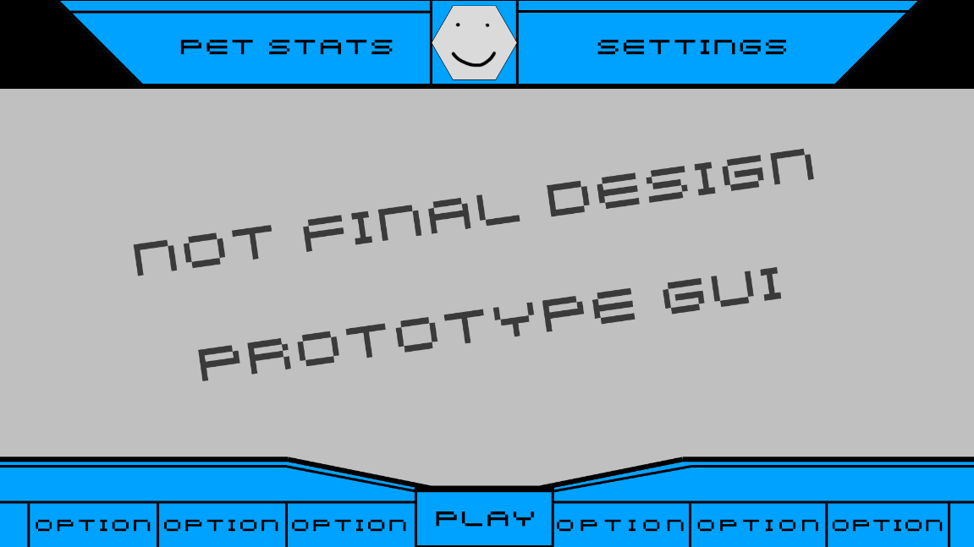

Figure 1: Design mock-up of pet mode GUI

The minigame GUI will differ in style but be similar in pet mode’s monochrome palette, with various options for the minigames the players can choose. A list of available games will appear, with a simple symbol for the stat the game will target e.g. muscle, smarts, fun et cetera. After choosing their minigame, the game will play a loading animation, then begin the minigame.

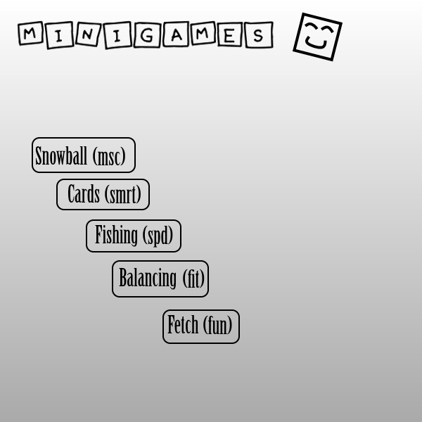

Figure 2: Mock-up GUI for the Minigame selection

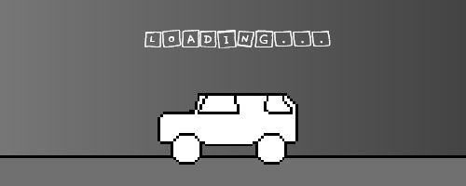

Figure 3: Mock-up GUI for Loading Screen

# **2.2 Visuals**

# **2.2.1 Visual Design**

Due to the genre of WebPetz, the visual style that has been chosen is an 8bit style similar to that of keychain virtual pets. This style fits the theme well, as the simple designs and limited resolution allows for more unique character and environmental designs. This style was done for necessity in the keychain games but here, it’s a specific style chosen for the style of gameplay. Sprite work also allows for better time management, as animations and details are simplified. Since this project is required for submission in under three months, the pixelated style works well for not only visual style but time as well.

Inspiration for the visual style has been influenced by keychain toys such as Tamagotchi and Sanrio’s many characters, like Gudetama and Hello Kitty. Tamagtochi has a similar visual style, especially when examining the earlier toys with limited screen size and technology. This limitation is what inspired the pixelated visuals for WebPetz, as graphical restrictions can lead to more focused designs with conserving space and detail.

The Sanrio inspiration is more specifically for the character’s visuals but also lends itself to the general visuals as well. Sanrio is known mostly for Hello Kitty but also have other characters such as Gudetama, Cinnamon, Aggretsuko and others. These characters, while having simple designs, convey a lot through of personality their simple shapes and colours. The goal is to recreate that sense of character through our designs, for characters, environments, props et cetera.

## **2.2.2 Pet Visuals**

The WebPetz are designed to reflect a specific attribute and evolved down a specific line depending on what attributes have been reached. This is somewhat like the way that Tamagotchi and Digimon had their evolution system, although WebPetz are designed to reflect stats with their design. The stats are as follows; muscle, smarts, speed, fun and fitness. For example, a WebPet with the “fun” stat prioritised may appear more jovial than other pets. When pets evolve once under a specific stat type, they will stay on that path until they pass away.

This section will talk about the different pets and their design, with pictures to show their stats and general look. The designs may vary in the final game but these mockups will provide good instructions on what each pet should look like.

**Omni -** A happier pet, Omni is a ball that values fun and games. Being happier, he is always seen smiling and appears more “plump” than other pets. As he grows older, he grows older and larger to show off more of his “plump” appearance. His body also starts to solidify as his baby body is quite “sludge” like. The purpose of his design is to precisely show of his nice and kind nature.

**Hachi -** A weird tentacle creature, Hachi represents fitness. With a constant angry look, Hachi isn’t as nice as some of the other pets. His body starts off pudgy but as he grows, his body grows bigger and stronger.

**Mitts -** Resembling a cat, Mitts is a feline pet that is sleek and fast. As Mitts grows older, his innocent smile turns into a grumpy look. He starts off as just a spherical creature but as he ages, his grows two legs that allow for his fast reflexes.

**Boinko-** An odd orb creature, Boinko isn’t good at much except being smart. He has small ear holes and buck teeth, sporting an odd twisty limb as he grows into a teenager. This limb starts to twist as he reaches adulthood and his smile grows larger. He also has a moustache and a pair of glasses when he reaches adulthood.

**Brick -** A literal rock, Brick values strength and muscle. Brick starts off as two rocks stacked on each other, with a rocky nose and slits for his eyes and mouth. As Brick ages into a teenager, his rocky form grows larger, looking like the form of a snowman. His arms begin to grow into two rocky “stubs”. As he becomes an adult, his “snowman-esque” body disappears, becoming a singular solid rock with larger arms that holds him up.

## **2.2.4 Concept Art**

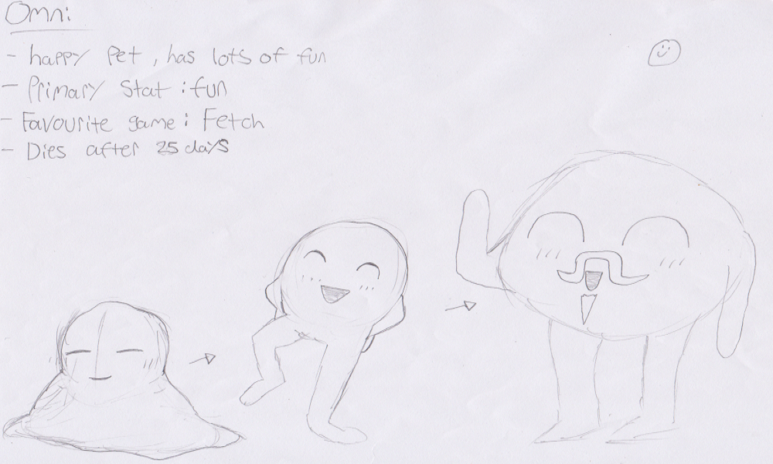

Figure 4: Concept art of Omni, the happy and fun pet

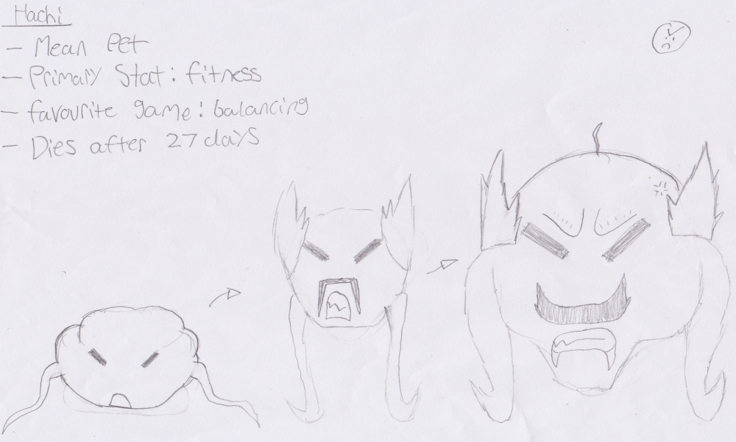

Figure 5: Concept art of Hachi, the mean and fitness loving pet

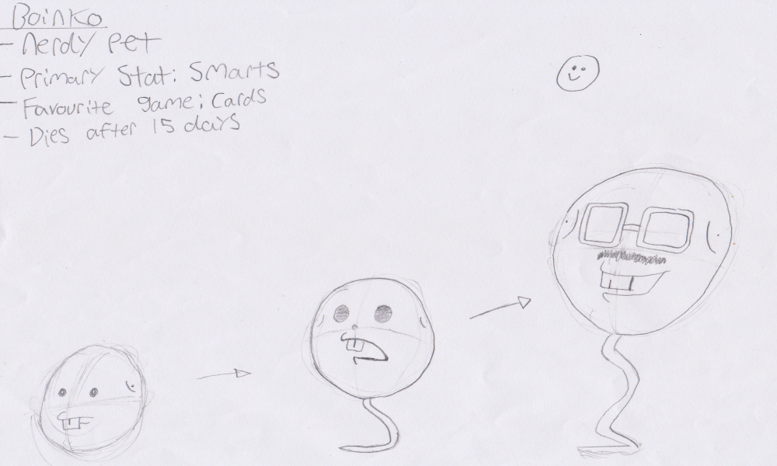

Figure 6: Concept art of Boinko, the nerdy and smart pet

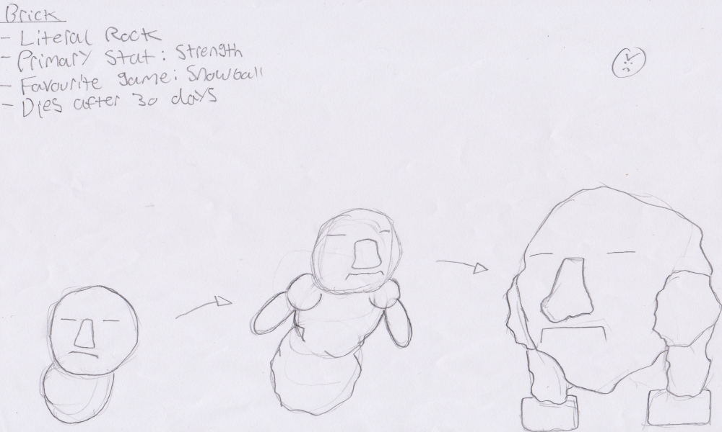

Figure 7: Concept art of Brick, the "literal rock" and strong pet

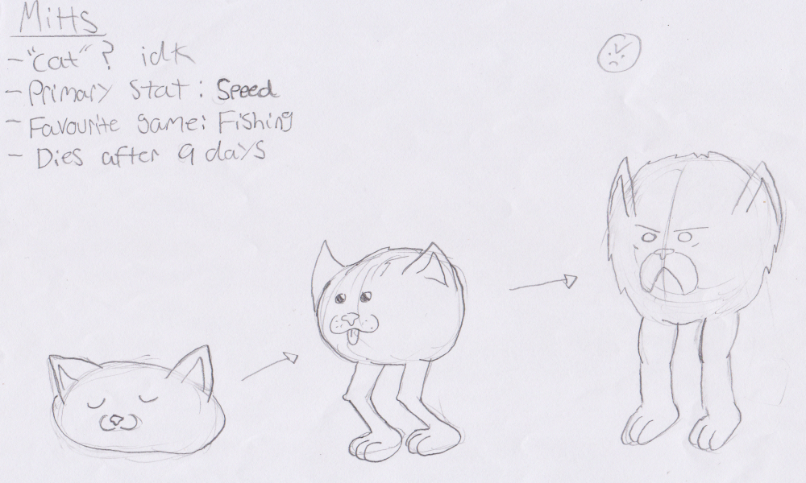

Figure 8: Concept art of Mitts, the "cat" and agile pet

# **2.4 Audio Design**

# **2.4.1 Sound Effects**

Sound effects tied to interaction with GUI should be kept to a minimum. If included, the sounds played should follow the same line of logic as monster barks; short in length, but effective in tone. All sounds made by the digital pets should be short in length but feel natural in tone. Especially so for monster ‘barks’, that should sound emotive, and relatable for each unique ‘monster’, and hint on its current condition or ‘mood’. To start simple, these moods should consist of four states;

* Happiness Bark, (when Happiness increases)
* Sadness Bark, (when Happiness decreases)
* Hunger check/bark (when pet is hungry)
* Affliction check/bark (if/when pet is hurt, or dying)

Though ideally, each monster should have their own ‘variation’ for their own barks. In practice, some corners can be cut if in practice it becomes hard to generate authentic monster sounds for one set of pets.

Within each mini-game, additional sound effects should be related to the ‘actions’ happening within the mini-games. Ranging from ‘quiet’ background sounds of wind, to the shuffling of cards, and impact of thrown objects upon. However, mini-game sounds are tertiary compared to including the audio cues from the monster pet’s condition, and response to key actions, within each mini-game. That said, a list of hypothetical sounds for mini games could consist of at least the following;

* “Throwing” sound, should be ‘swoosh’ like
* “Running” sound, should be ‘tap’-like
* “Hit” sound, impact wise.
* “Balance” sound, if a pet’s about to fall or lose.
* “Jump” sound, if there’s a 2d platform mini game included.

For simplicity sake, I highly suggest the use of the program “Bfxr”, as it is a simple audio effect’s generator that is not only free to use but enables complete ownership of rights for all sounds generated using this tool. Though it may not sound realistic to a modern-day perspective, it’s sound can tap into a ‘nostalgia valley’ for old users, especially when pertaining to the monster pet market.

# **2.4.2 Background Music**

The key ‘themes’ for the background music should be “retrowave” (or the limitations of early gen games consoles) and “cartoony” (to fit within the ‘theme’ of a monster taming game, aimed at children.) For time constraints, audio should be outsourced and fit most, if not all the key “themes” for utilizing Background Music, whilst still being free to use for an educational project, permissions wise.

Depending on what assets are accepted for audio, an additional credits page may be required to credit the authors, specifically if an “Attribution” clause has been added to the asset’s copyright by the author of the asset themselves. The music should fit within a minimum of two ‘themes’, the “Background” music, and a “game” theme; with different versions of game themes potentially allowed, if they fit the ‘theme’ of the mini-game in question.

# **2.4.3 Examples of Similar Audio**

# **2.4.3.1 Sound**

A codifier for monster sounds is Pokémon. Particularly the earliest “Gameboy” era, when it comes to the field of monster barks.

Another example is Tamagochi, particularly when it comes to placeholder, or UI-linked sound effects. However, the way it conveys monster sounds can at best, be simplistic.

A last example, based on the medium of web games (in a mobile perspective), is the game “Pou”, that can serve as an additional reference and example of mixing monster audio to sound cues, and what audio cues need to be included within each mini-game at a minimum.

# **2.4.3.2 Background Music**

To fit within the musical genre/themes of “8-bit”, or “Cartoony”, whilst being as public domain and usable as possible, for educational use. Ideally, the ‘tone’ of the music should feel similar to other monster/digital pet games such as Pokemon, Digimon and Tamagochi, genre wise. Here are some potential sources of audio that could be used within the project itself.

OpenGameArt is one easy source for background music, that can easily fit within the “8-bit” music genre.

FreePd is another site that boasts an archive of free to download and use “CC0” (that is copyright waved to public domain) music, that at a casual glance can easily fit within the “Cartoony” genre of music. However, it comes with a limit to how much/many sounds can be downloaded at once.

# **3. Technical**

# **3.1 Implementation**

# **3.1.1 Mechanics**

**Evolution**As the pet ages, they will get a chance to evolve to the next stage of either their current path or a brand-new path. If a pet has a certain stat over a certain value, they will evolve to that stats’ next stage when the “evolution trigger” has been reached. As an example, if the player owns a child Omni, the child will evolve after two hours. If the child Omni has their fun stat above ten, then the next stage of their evolution will be the teen Omni. However, if the player instead decides to change their primary stat to “muscle”, then when they evolve, they become a teen Brick.

This system allows the player to change their pet’s look if they desire, as each pet’s evolution line will look quite similar. The player will be able to download the growth chart so they can plan their evolution as much as they desire.

**Pet Caring**

Playing with your pets is important but another thing to keep in mind is the pet’s happiness and general health. As common in other pet games, your pet is susceptible to death, so care must be taken to stave off the inevitable. By using the pet game’s GUI, the player will be able to feed their pet, which fills a hunger bar. The hunger bar will contain a max value of four, which is the pet’s max hunger. If you attempt to feed the pet when this value is maxed, your pet will become fatter and may even die early as a result. The hunger bar will decrease and increase at varied times, depending on the evolution stage that the player’s current pet is at. For example, child pets will require more food than an adult et cetera.

As pets eat and sleep, they will become dirtier, which will be shown by a visual effect. A dirty pet will become sick and be at risk of death. A command for cleaning the pet will be shown in the GUI, which will shower the pet and raise their “cleanliness” stat back to full.

**Death**No matter how well a pet is taken care of, it will eventually die, and the player will start the pet care from the beginning. As the pet dies however, they will transform into one last form. This form will take the image of either an angel or devil. This is a visual indicator of how many “mistakes” were made during care or how happy the pet was. By reaching a certain number of mistakes or happiness, your pet will transform into a demon, otherwise they will become an angel.

## **3.1.2 Multiplayer**

**Multiplayer Lobby Startup**

There are many ways to do a multiplayer lobby, checking for players logging in, or joining someone else playing online, but as this is local multiplayer, there had to be a more sophisticated way of doing such things.

Instead of having players locked down, the pets they can use within multiplayer are generated with a string key. The key is a combination of the stats and values to create a pet they can use. Within a singleplayer game, there will be a button to generate a key for their use, which they can then use to load later on in the future. This key is also what is requested when starting the multiplayer lobby off. Each player will enter a valid key or select one of the preset pets, before beginning and then after both players are ready to play, they can select their gamemode and get into the game.

**Input**

Local multiplayer works the same way with input detection, as a singleplayer game would, where the input per player is detected through a set of keys. An input handler class will be made with a child object that will contain all the input settings for each player and the boolean checks for each detection type (key press, key release, etc.). This system will be modular, and the class will be instantiated individually for each player, in this case 2. It can be extended into controller data too, if that is specifically required, but for the simple games, 2 player limitation, splitting the keyboard controls will be suitable.  
  
**Minigames**Minigames will be based on certain stats, so when the players play them the dedicated stat will raise. The different minigames are as follows:

* Snowball – A strength based versus game, where both players must hit each other with snowballs and take cover behind a giant snow pile. The first one to hit a certain value, for example ten, then that player wins.
* Rock, Paper, Scissors – Inspired from the card game idea, RPS is an intelligence based minigame where the players play a typical game of rock paper scissors. The games play best two out of three.
* Fishing – An agility-based minigame, both players must catch as much fish as possible within a certain time limit. This will require players to wait for certain queues which might be accidentally missed if they’re not paying attention.
* Balancing – A fitness based minigame, balancing will put one or both pets on the balancing pole for a certain amount of time (or until one falls off). This game will function like “Simon Says” where instructions are shown and players need to follow the command, avoiding intentional “distractions”. For example, the text may say “Tap right!” then show a left arrow beneath the text.
* Fetch – A fun activity, fetch functions like frogger, where each player needs to make their way to a “stick”, while avoiding hazards. This goes on until one reaches the stick or the time runs out.

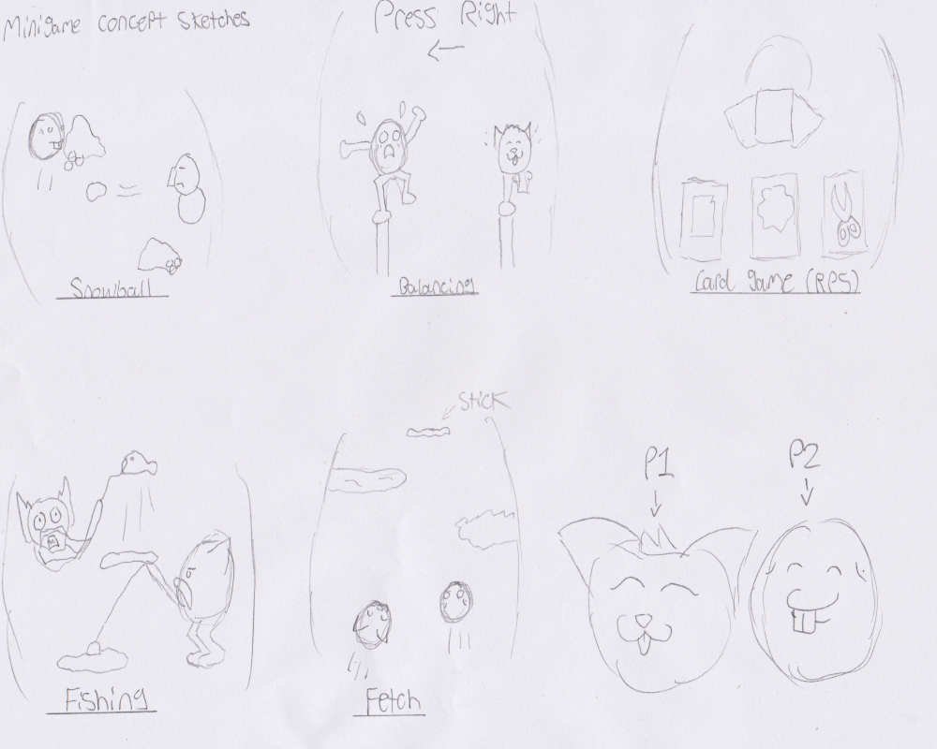

Figure 9: Concept sketches of Minigame layout

# **3.1.3 Gameplay Loop**

**Pet Growth and Development**

As the gradual development of a pet happens, changes will be seen in their design and statistics. Utilising the main update method and applying a global update value that changes through this method each frame, the age of the pet can be calculated. The development is evaluated in two ways:

1. For general “life” and age checks. As the pet gets older, at a certain point, it’ll reach the near end of its life, and there will be a random chance for the pet to die. Depending on the evaluation of its behaviour throughout its life, the death of the pet will appear in two different forms, being a good devil or an angel to visualise if the player cared for the pet or not.
2. After stat growth has been achieved, depending on what stat reached specific thresholds (which will be set internally for each state individually), the pet will evolve into a stronger evolution compared to its current form. This however, is unlike normal evolution designs, where instead of being locked down to the same evolution path, the next form above is fluid in the sense that if another stat is then above the “next level” threshold compared to the current level evolution, it’ll change into the form for that stat progression.

## **3.2 Software & Hardware**

# **3.2.1 Software**

The game must run server side, able to be accessed through a browser, which must include full support and access of HTML5, along with features including the ‘canvas’ feature for the game itself. Though at a minimum, it should be accessible from a desktop browser, ideally the game should also function through a mobile browser along with interface. On that end, the use of GitHub as an external storage, as a backup service on top of also a potential website using “GitHub Pages”, will ensure the requirements in getting a functional web game, hosted on a website.

Server wise, if GitHub pages can’t be relied upon a particular piece of software, WampServer, or WAMP is a virtual server that is also very useful in configuring a custom web server, by installing Apache, MySQL and PHP at the same time, and designed for Windows.

One other aspect to be aware about while setting up a web server, is “Port Blocking”. There can be numerous reasons why a port might be blocked by an Internet Service Provider, relating to security. But if a port is blocked, the easiest solution would be to use another/different port number.

Though the code itself at a minimum can be easily edited using Notepad++, or any other text editor for HTML, JavaScript and CSS. Along with also requiring the additional reference/inclusion of internet “Cookies” to store data between sessions.

Ideally, using a “Integrated Development Environment” (IDE) for built-in error checking, code and markup completion, or auto-correcting of code for corrections and suggestions, in regards to HTML, JavaScript and CSS functionality. A good example of an “IDE” that is available for free use, would be “Visual Studio Code”, that comes with the “IntelliSense” feature of automated syntax suggestions, along with built-in support for Git for version control and backup, as well as being easy to further customize. Alternatively, there exists a premium service called “WebStorm”, that also features additional support for Node.js and Meteor.

There are also a couple of recommended external libraries for HTML, JavaScript and CSS that enable simpler, and easier development of web pages, and web applications. Of which, “Bootstrap” is useful in formatting web pages. While “JQuery” is useful for adding easy features and design to create interactive or more detailed websites.

On top of all other external libraries, especially for web applications; is the fact that developing a web game can be difficult to do in a short timeframe, especially when said game has to include multiplayer interaction and functionality, which would take an entire module just to figure out on building the tool/s TO make the game from a referenced library. Thus, in order to accomplish that, Phaser 3 is being used as an external game library for code functionality. Specifically, “Version: 3.21.0 - ‘Senku’” as a framework for the game to make the development easier, and thus quicker to implement to a prototype degree.

There also has to be another function within the webpage itself to enable the storage, saving and loading of data from the website’s current state from the user, for later reloading upon re-opening of the web-page itself. Of which, the most promising external language format for data storage is the “JSON” file format, which is an extension of JavaScript that is used in the storage of data for the pet’s stats and state, but also aid in declaring animation variables for the sprites themselves, upon a set criteria, such as low health or has been excited or angered, among other potential states.

For 2d images, a comprehensive, open source software to default to is “Paint.net”, that features functional tools and layer editing.

Alternately, on a commercial end. We can also consider the use of the software “Aseprite”, that is nested with features that make it optimised for 2D sprite based animation, which can then be saved in both PNG and GIF formats, and can even import/export sprite sheets, along with additional support for JSON files for additional animation data.

For simple, easy to generate audio cues, **“Bfxr.”** is a perfect example for quickly generating 8-bit sound folly. A downloadable, online tool used to generate sound effects for games, that is free for use and grants unconditional ownership of sounds made using this tool to the user themselves.

Further audio editing can be done if required, using **“Audacity”**. A free, open source audio software that can enable simple editing of audio into a wider variety of formats, and various lengths if need be.

## **3.2.2 Hardware**

For the end user they must, at a minimum, be able to access the web page itself, which must at a minimum support HTML5 features, including the use of canvases and audio. Though it might “require” Windows 10, given the nature of modern web browsers, chances are it ‘could’ also work on a Mac web page/browser, as much as a Linux web page/browser, but we can’t verify that due to a lack of personal resources. So on that end, the question goes to what hardware would we require for the Web Server itself, along with the development of the assets for the game. The answer to that, is that we don’t need “much” in the way of graphical processing power, just a decent CPU, RAM and enough storage to contain the entire work assets for the project itself, at a minimum. While for the user, for said hardware to be “good” enough to run the operating system itself, and a few more basic use programs on top.

That said, if we have to run an offline server, instead of using an online cloud service such as GitHub for the storage and sharing of our web content. Then odds are we’ll need more hardware, enough to run a web server. Of which, having one or two “1.6 GHz” CPUs, at least 4 GB of RAM, and between 40/80 GB of Hard Disk Storage, is recommended at a rough minimum, especially taking into account the small-scale scope of our project, in contrast to bigger companies and servers.

Lastly, if custom assets are to be created physically, then we need nothing more than a digital scanner, along with a microphone for later inclusion and editing of the assets for the web game itself.

# **3.3 Scripting/Pseudocode**

**Read/Load Stats from JSON file/cookie**

IF Saved Data is found in Cookies/browser (tag wise)

THEN LOAD Pet and their Stats, from Cookie File

ELSE

CREATE a new pet, from the start. Set base stats to zero/average.

ENDIF

**Save Pet Stats to browser Cookie/JSON file**

IF no data file is found

THEN CREATE a new data file in database folder, containing the pet’s current stats

ELSE IF a data file is found

THEN OVERWRITE the data file in database folder, containing the pets current stats

ENDIF

**Pet Stat Values**

Min Stat = 0

Max Stat = 50 (or 100)

Spawn Time = “Date of Birth” (Time + Date)

Age Gate (Death) = 1 - 5 Days (check ‘if’ 24/120 hours have passed since birth?)

Key = “Chosen Stat” from pet stats list, to improve from a minigame (running, jumping, etc.)

**Increase Pet Stat** (variables Stat & Value)

Increment (Stat) by (Value) amount

IF (Stat) is beyond max/cap value,

THEN set (Stat) value to max/cap value

ENDIF

**Decrease Pet Stat** (variables Stat & Value)

Decrement (Stat) by (Value) amount

IF (Stat) is below min/cap value,

THEN set (Stat) value to min/cap value

ENDIF

**Age up Pet by time**

Age = Current Time -= “Spawn Time” (only take into account ‘time difference’, code wise.)

IF Age < 1 Minute

THEN Pet is at Egg Stage

IF Age >= 1 Minute

THEN Pet is at Baby Stage

IF Age >= 1 Hour (or 10/30 Minutes)

THEN Pet is at Child Stage

Check evolution “Chart”

IF Age >= 2 Hours (or 1 Hour)

THEN Pet is at Teenager Stage

Check evolution “Chart”

IF Age >=4 Hours (or 2 Hours)

THEN Pet is at Adult Stage

Check evolution “Chart”

ENDIF

**Old Age Stage**

IF Age >= DayCheck Value (1 Day)

THEN Roll a chance to see if pet dies?

IF Pet fails the ‘check’

THEN Kill Pet

Reset “DayCheck” Value to 1 (Day)

Increment “DayCheck Value

IF Age >= “Max Age” (5 Days)

THEN Kill Pet

Reset “DayCheck” Value to 1 (Day)

ENDIF

**Pet Evolution Chart (Code)**

IF Any Pet Stat >= (“Pet” State value * 5), and NOT related to wellbeing stats (Happiness, hunger...)

THEN Evolve the pet to next state, depending on the stat above (“Pet” State value * 5)

ELSE IF “Pet Stage” is different to current pet stage

THEN GET Highest stat ‘value’, from pet’s current stats

Evolve the pet to the next stage, depending on the highest stat. (Muscle = A, Smarts = B…)

ENDIF

**Early Death Code? (If implementing ‘stat caps’ for evolve a pet by?)**

IF Hunger = 0, by next pet stage

THEN Kill Pet

ENDIF

IF Pet is not at Child or Baby stage

IF Pet is at Teenager stage, and Any Pet Stat NOT >= 4

THEN Kill Pet

ELSE Pet is Adult, and Any Pet Stat NOT >= 8

THEN Kill Pet

ENDIF

ENDIF

**Mini-game selection (base on HUD Choices, GUI wise)**

IF “Keyed” Button is pressed

THEN Load “Phaser” Game within the phaser game.

SET “Key” value to the value within that minigame (Running, jumping, etc.)

RUN Mini-game

**Gameplay dependent Pseudo-code (Example)**

“Read gameplay code” (varies, dependant on each mini-game)

“Run gameplay code” (varies, dependant on each mini-game)

AT End of Gameplay

Translate SCORE into Value (Increment, Target Stat)

Translate TIME into Value (Increment / Decrement)

IF Gameplay was too short (unfun)

THEN Remove (from 1 to 3) from (key) stat as a penalty (Decrement)

Remove (from 1 to 3) from fun as a penalty (Decrement)

ELSE Gameplay was long enough

THEN Add (from 1 to 3) to (key) stat as a reward (Increment)

Add (from 1 to 3) to fun stat as a reward (Increment)

ELSE

Add 1 to (key) stat as a reward (Increment)

THEN

Close Phaser Mini game

ENDIF

# **3.4 Software Development Life Cycle**

Due to the quick development and iteration that will happen throughout the creation of the game, the development lifecycle used for WebPets is Agile. Due to there being no set class design or set system created prior, changes in development and iterative development will be highly important to make sure that the project continues to progress.

[](https://www.google.co.uk/url?sa=i&url=https%3A%2F%2Fwww.tatvasoft.com%2Fblog%2Ftop-12-software-development-methodologies-and-its-advantages-disadvantages%2F&psig=AOvVaw3Dh2L3oQ3mdh5n7axl6dfO&ust=1585680143215000&source=images&cd=vfe&ved=0CAIQjRxqFwoTCMiMwYDtwugCFQAAAAAdAAAAABAp)

Figure 10: Agile SDLC (TatvaSoft, 2015)

This also allows for a loose development process between the team, so that each member can work on their own specific tasks separately to everyone else. Github will support this approach, using branches for systems that are in progress. After they’re finished, they will be pushed to the master, making sure no conflicts happen. Due to its’ focus on communication, Agile makes the project suitable in feedback between lecturer and students.

While agile may be great for the project, the cons must be considered as well. Agile is very flexible, which while good, also makes managing the project more difficult. Unlike a more structured Waterfall or Spiral, Agile is more susceptible to human error and laziness because of its’ structure. Using Agile means the team must be vigilant and stick to their goals, if they want to avoid the main drawback of Agile. Similarly, a lack of real structure could also make development more tedious as structure allows more streamlined and simple development.

# **4. Project Management 4.1 Project Schedule**

In this section, a rough schedule will be created to reflect our development tasks and deadlines for the second assessment. This schedule may be updated to reflect development changes and updates.

**Game Development**Set up a GitHub for the project and assign team members to separate branches *(3rd - 5th February)* - Damian  
Research code/implementation required for the game *(5th - 12th February)* - Andrew & Damian  
Begin development of the pet game prototype *(14th February - 28th February)* - All  
 Develop UI reflecting the game’s design *(16th February)* - Andrew  
 Create pet object and a couple of test pets e.g. Omni & Hachi *(17th February)* - Ross  
 Create a game loop simulating real-time progression, where things update as time progresses

*(17th February)* - Damian  
 Allow control for two players on the same screen *(24th February)* - Andrew  
 Store a second pet that can be spawned for a second player (*26th February)*

Begin development of the minigame prototype *(28th February - 13th March)* Develop snowball minigame *(29th February)* Develop balancing minigame *(2nd March)* Develop fetch minigame *(4th March)* Develop fishing minigame *(6th March)* Develop card game *(10th March)*Polish for Deadline *(13th March - 20th March)* Integrate both the pet game and minigames *(14th March)*Hand-In *(March 25th)*

**Assets & Animation**Create sprite sheets for each pet and their evolutions *(5th February - 15th March)*  
 Create Omni’s sheet *(5th February - 14th February)* Create Hachi’s sheet *(15th February - 18th February)* Create Brick’s sheet *(20th February - 24th February)* Create Boinko’s sheet *(24th February - 28th February)* Create Mitt’s sheet *(29th February - 3rd March)* Create default baby’s sheet *(4th March - 8th March)* Create angel’s sheet *(8th March)* Create devil’s sheet *(9th March)* Create egg sheet *(9th March)*Create/Source additional assets *(15th March - 20th March)*

## **4.2 Needed Assets**

This section will briefly discuss some of the assets that may be required for WebPetz. This will be represented in a table. Most of these assets will be created, although some will need sourced.

|  |  |  |
| --- | --- | --- |
| Asset Type & Name | Function | Importance |
| Spritesheet - Omni (Child, Teen, Adult) | Used for the three stages of the “fun” pet, Omni. | Very Important |
| Spritesheet - Hachi (Child, Teen, Adult) | Used for the three stages of the “fitness” pet, Hachi. | Very Important |
| Spritesheet - Boinko (Child, Teen, Adult) | Used for the three stages of the “smarts” pet, Boinko. | Important |
| Spritesheet - Mitts (Child, Teen, Adult) | Used for the three stages of the “speed” pet, Mitts. | Important |
| Spritesheet - Brick (Child, Teen, Adult) | Used for the three stages of the “muscle” pet, Brick. | Important |
| Spritesheet - Assets | A spritesheet used for separate assets, such as fishing rods, snow et cetera. | Important/Normal |
| Audio - Minigame Music | A variety of music that would play for the suitable minigame. | Important |
| Audio - SFX | General sound effects needed for the game, both pet game and minigames. | Very Important |
| Spritesheet - UI | A singular sheet that contains all the UI assets needed for the pet game and minigames. | Important |

# **5. Term 2 Updates**

## **5.1 Gameplay**

When developing the gameplay and levels, a few changes were made both due to design improvements and time constraints. These are most apparent in the minigames; snowball, fishing and fetch. The other two minigames, balancing and card game, were not implemented due to time constraints. Animations for these games were made but couldn’t be utilised.   
  
Discussing design changes, the way that snowball, fetch and fishing is played was changed to better suit gameplay. Snowball allowed for both horizontal and vertical movement, as opposed to a restricted “vertical movement”. These new movement changes allowed for angled snowball shots that could improve gameplay choice, rather than a straight horizontal shot. Fishing was similarly changed but not just in gameplay but level layout. Instead of two small puddles with random chance, the players now stand at either end of a large pool while seeing the fish. They can then use their timing skills to cast their rod and catch a fish, rather than simply hope they catch one. Fetch is still familiar yet allows for the player to catch multiple sticks against a time limit.

The pet screen still allows for two pets but instead of a separate menu, the player can now select minigames while in the pet screen. There was little reason to split up the menus, so they were combined into one scene.

## **5.2 Visuals**

The visuals of WebPetz has stuck to a pixelated look but the colour palette changed as assets were developed. Originally, the game was set to a black and white aesthetic but was decided to mirror the look of typical keychain toys. This look has coloured backgrounds, with “see through” sprites for the pets. All webpetz will be invisible with no colour and black outlines, resembling their keychain inspirations. Backgrounds will still be pixelated but may have a higher pixel count than the pets’ 32x32 size.

All pets were given animations but not every pet was used for the final game; due to not implementing each minigame. Boinko was originally going to be used for the smarts based minigames, such as “rock paper scissors” but unfortunately could not be utilised as the game wasn’t implemented. Hachi was also cut from the game, as his balancing game wasn’t implemented either. If development would continue, these pets would have been added.

The pets no longer become an angel or devil after they die, instead they simply become a standard gravestone. To save development time, it was decided to simply use a static gravestone to convey that the pet has died. Perhaps this feature might be changed in the future but for now, a static gravestone will suffice.

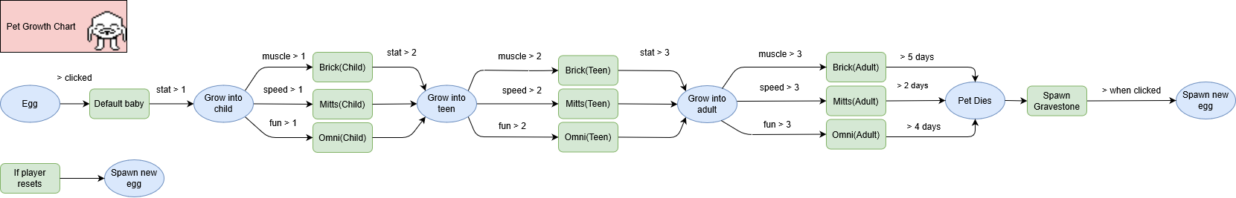

Figure 11: Updated Pet Chart

# **6. References**

Asmule, 2019. *Pou Game #10.* [Online]   
Available at: https://www.youtube.com/watch?v=zVwdbeWet2A  
[Accessed 17 January 2020].

AudacityTeams, n.d.. *Audacity ® | Free, open source, cross-platform audio for multi-track recording and editing..* [Online]   
Available at: https://www.audacityteam.org/  
[Accessed 13 January 2020].

bfxr, n.d.. *Bfxr. Make sound effect for your games..* [Online]   
Available at: https://www.bfxr.net/  
[Accessed 13 January 2020].

Bitag, 2013. *Port Blocking - A Uniform Agreement Report,* s.l.: s.n.

BootStrap, n.d.. *BootStrap | The most powerful, HTML, CSS and JS library in the world.* [Online]   
Available at: https://getbootstrap.com/  
[Accessed 12 January 2020].

Caden, C., 2019. *Logging On Webkinz 12 Years Later.* [Online]   
Available at: https://youtu.be/8NTgVU29YCs  
[Accessed 17 January 2020].

David Capello, I. S., 2016. *Aseprite.* [Online]   
Available at: https://store.steampowered.com/app/431730/Aseprite/  
[Accessed 25 January 2020].

Evie, C., 2011. *40 Pikachu voices (Pokémon Yellow).* [Online]   
Available at: https://www.youtube.com/watch?v=LNV4P3DFPps  
[Accessed 12 January 2020].

freepd, n.d.. *FreePD.com - Free Public Domain Music Creative Commons 0 Completely Royalty Free.* [Online]   
Available at: https://freepd.com/  
[Accessed 13 January 2020].

gameboyadvance45, 2016. *TAMAGOTCHI 1996 SOUND EFFECTS OST.* [Online]   
Available at: https://www.youtube.com/watch?v=aoVaAutNJPM  
[Accessed 15 January 2020].

Github, n.d.. *GitHub Pages | Websites for you and your projects, hosted directly from your GitHub repository. Just edit, push and your changes..* [Online]   
Available at: https://pages.github.com/  
[Accessed 21 January 2020].

JetBrains, n.d.. *Webstorm : The Smartest Javascript IDE by JetBrains.* [Online]   
Available at: https://www.jetbrains.com/webstorm/  
[Accessed 23 January 2020].

josepharaoh99, 2017. *CC0 - Retro Music | OpenGameArt.org.* [Online]   
Available at: https://opengameart.org/content/cc0-retro-music   
[Accessed 15 January 2020].

Le, K., 1997. *Tamagotchi Official Instructions.* [Online]   
Available at: http://members.tripod.com/~Tamagotchi_Central/instructions.html  
[Accessed 17 January 2020].

MathPlayground, n.d.. *Duck Life 4 | Math Playground.* [Online]   
Available at: https://www.mathplayground.com/logic_duck_life_4.html  
[Accessed 15 January 2020].

Mozilla, n.d.. *HTTP cookies - HTTP | MDN.* [Online]   
Available at: https://developer.mozilla.org/en-US/docs/Web/HTTP/Cookies  
[Accessed 25 January 2020].

Phaser, 2019. *Phaser - Download - Phaser 3.21.0 "Senku".* [Online]   
Available at: https://phaser.io/download/release/3.21.0  
[Accessed 12 January 2020].

Sana, n.d.. *Hardware Requirements for Web and Data Servers.* [Online]   
Available at: https://help.sana-commerce.com/sana-commerce-83/installation/setup-web-and-database-server/hardware-requirements-for-web-and-database-servers  
[Accessed 20 January 2020].

Tamagotchi, n.d.. *Tamagothci On - by Bandai America Inc..* [Online]   
Available at: https://tamagotchi.com/  
[Accessed 14 January 2020].

ThejQueryFoundation, n.d.. *jQuery.* [Online]   
Available at: https://jquery.com/  
[Accessed 15 January 2020].

WampServer, n.d.. *WampServer.* [Online]   
Available at: http://www.wampserver.com/en/  
[Accessed 15 January 2020].

Wikimon, n.d.. *Digital Monster Ver.20th.* [Online]   
Available at: https://wikimon.net/Digital_Monster_Ver.20th  
[Accessed 15 January 2020].

Wikipedia, n.d. . *Webkinz.* [Online]   
Available at: https://en.wikipedia.org/wiki/Webkinz  
[Accessed 20 January 2020].

# **7. Appendix**

**Old game notes and design**

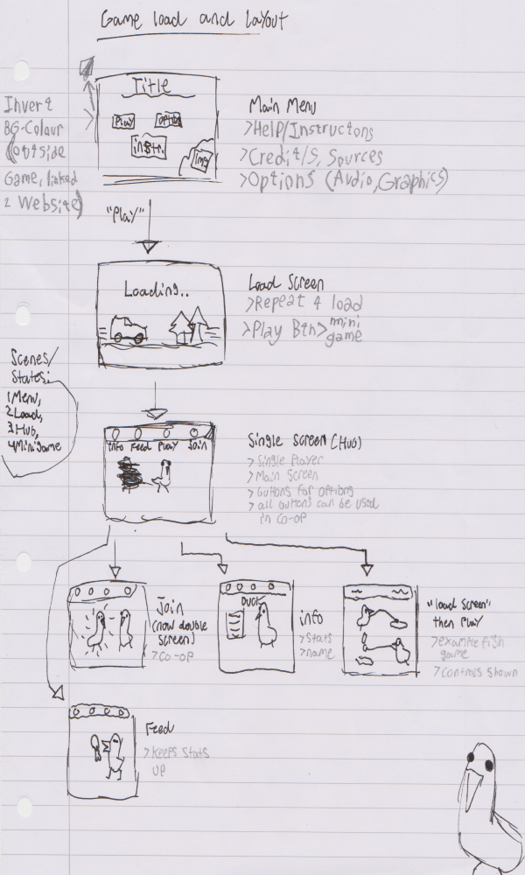

Figure 12: Brainstorm UI Layout and Flow

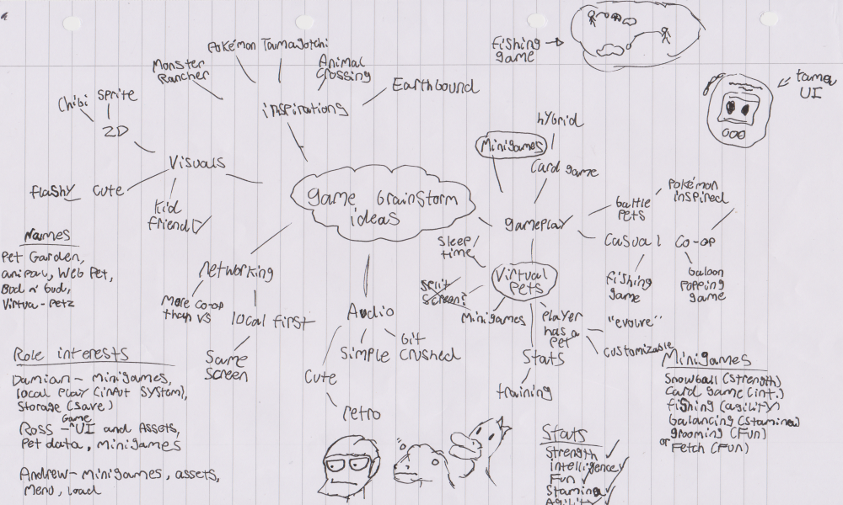

Figure 13: Spider web brainstorm (start of design)

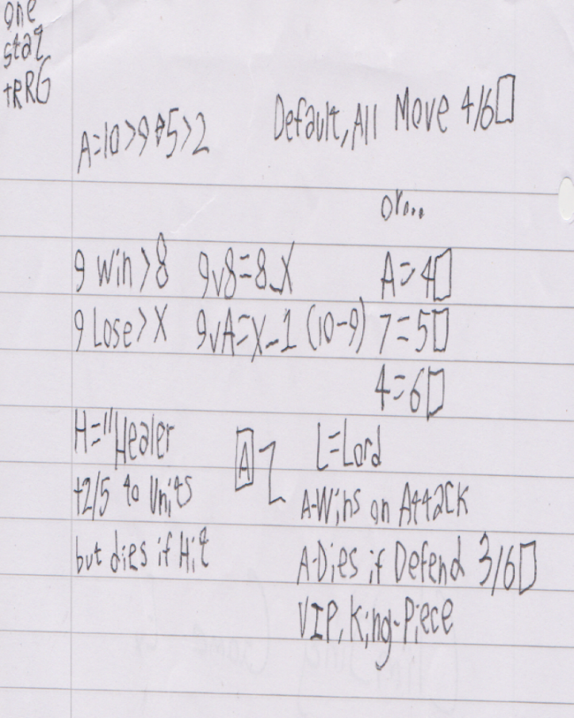

Figure 14: Notes on "Card game" Logic

**Sound Credits**

All sounds have been custom made using the sound effect generator "Bfxr." Which was all made/edited by Andrew Irvine Letailleur, who is in charge of the audio for this project.

All music used has been outsourced from the site "OpenGameArt.org". Specifically, all tracks used has been placed under the "No Rights Reserved", or CC0 license. That is the legal/copyright equivilent of Public Domain.

The precise tagline used to find all the music tracks, alongside the web link is provided below;

https://opengameart.org/content/cc0-retro-music

=Authors and Credits=

(Main/Pet theme/BGM) "Talking Cute (Chiptune)", 2017, September 17. By "Pro Sensory", under the name "Alex McCulloch". CC0. Available at; https://opengameart.org/content/talking-cute-chiptune

Note that this track has been edited to last half as long, using Audacity. Which has also been used to lower the quality of the audio to a managable size in memory, without affecting the fidelity of the audio itself.

[Last Accessed 30 March, 2020]

(Snowball BGM) "Rewind", 2017, September 17. By "Pro Sensory", under the name "Alex McCulloch". CC0. Available at; https://opengameart.org/content/rewind

Note that this track has been edited to last half as long, using Audacity. Which has also been used to lower the quality of the audio to a managable size in memory, without affecting the fidelity of the audio itself.

[Last Accessed 11 March, 2020]

(Fetch BGM) "Tropical Fantasy", 2017, December 2. By "Spring". CC0. Available at; https://opengameart.org/content/tropical-fantasy

Note that this track has been edited to last one third as long, using Audacity. Which has also been used to lower the quality of the audio to a managable size in memory, without affecting the fidelity of the audio itself.

[Last Accessed 11 March, 2020]

(Fishing BGM) "Puppy Playing in The Garden", 2019, June 27. By "Spring". CC0. Available at; https://opengameart.org/content/puppy-playing-in-the-garden

Note that this track has been edited to last one third less than the original, using Audacity. Which has also been used to lower the quality of the audio to a managable size in memory, without affecting the fidelity of the audio itself.

[Last Accessed 30 March, 2020]

(Balancing BGM) "Heckin' Crow", 2019, October 6. By "congusbongus". CC0. Available at; https://opengameart.org/content/heckin-crows

[Last Accessed 13 March, 2020]